Pre test for geometric educational module
Specific questions (open ended)

1. What does the term “stereology” mean?

2. A man is holding a ball in the air as a light source and shines on the ball directly at the ball at a horizontal level. What shape do you expect the ball's shadow to form on the wall?

3. A light source is shining on one side of a cube at a horizontal level. What shape will the cube's side take on the wall?

4. What would the image from (3) appear as on the wall? (Draw the image).

5. Suppose one had a tumor in one’s lungs that could be detected with a dye that would show up on an X-ray. You have a chance to pin point the tumor before surgery but you only have ability for two X-rays. What two positions would be best to take these 2 X-rays? Draw diagrams and explain your answers.

6. Would the angle like structures in block A & B project the same size area outline on a 2-D plane? Assume the light source is the same distance away from both, directly on the seam (or middle corner) of the angle in both blocks and the structures are of equal dimensions.
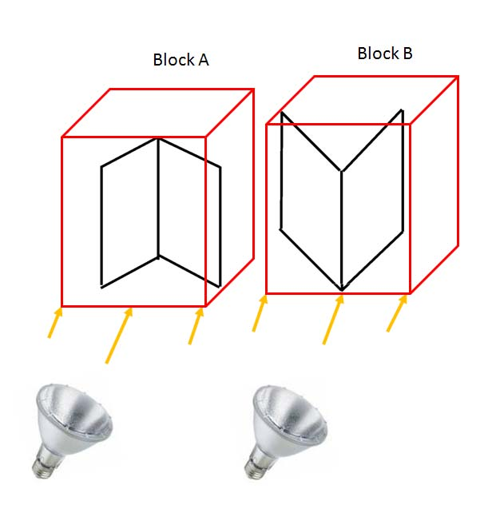
7. Below light A is directly facing one side of the box, but light B is facing the corner of the box, and both are the same distance from the box. The box is 1 cm on every side. Draw the estimated image projected for light A and light B at a horizontal levels. Are the images the same size?

